AZURE SETUP – DATABRICKS

[Jobaoushadancse2021@jerusalemengg.ac.in](mailto:Jobaoushadancse2021@jerusalemengg.ac.in)

Job Aoushadan N – 06.08.2025

1. By generating your login credentials open Azure , you can see the interface

Shown below:

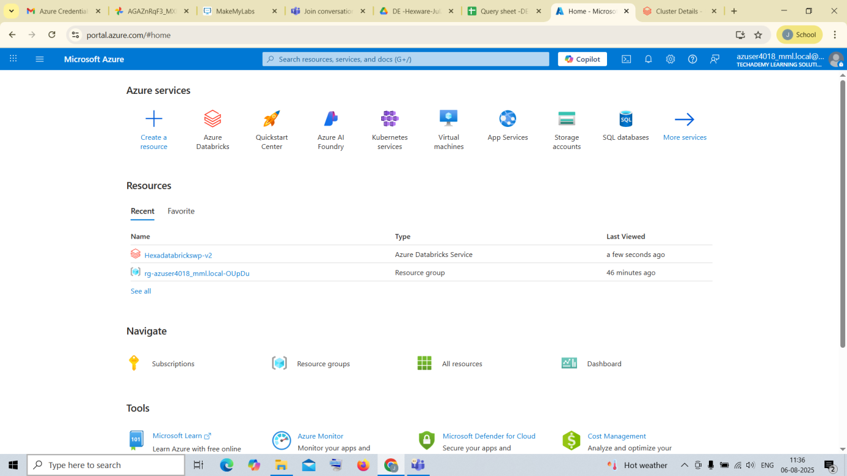

1. Click on create ,to create a new Azure Databricks Service

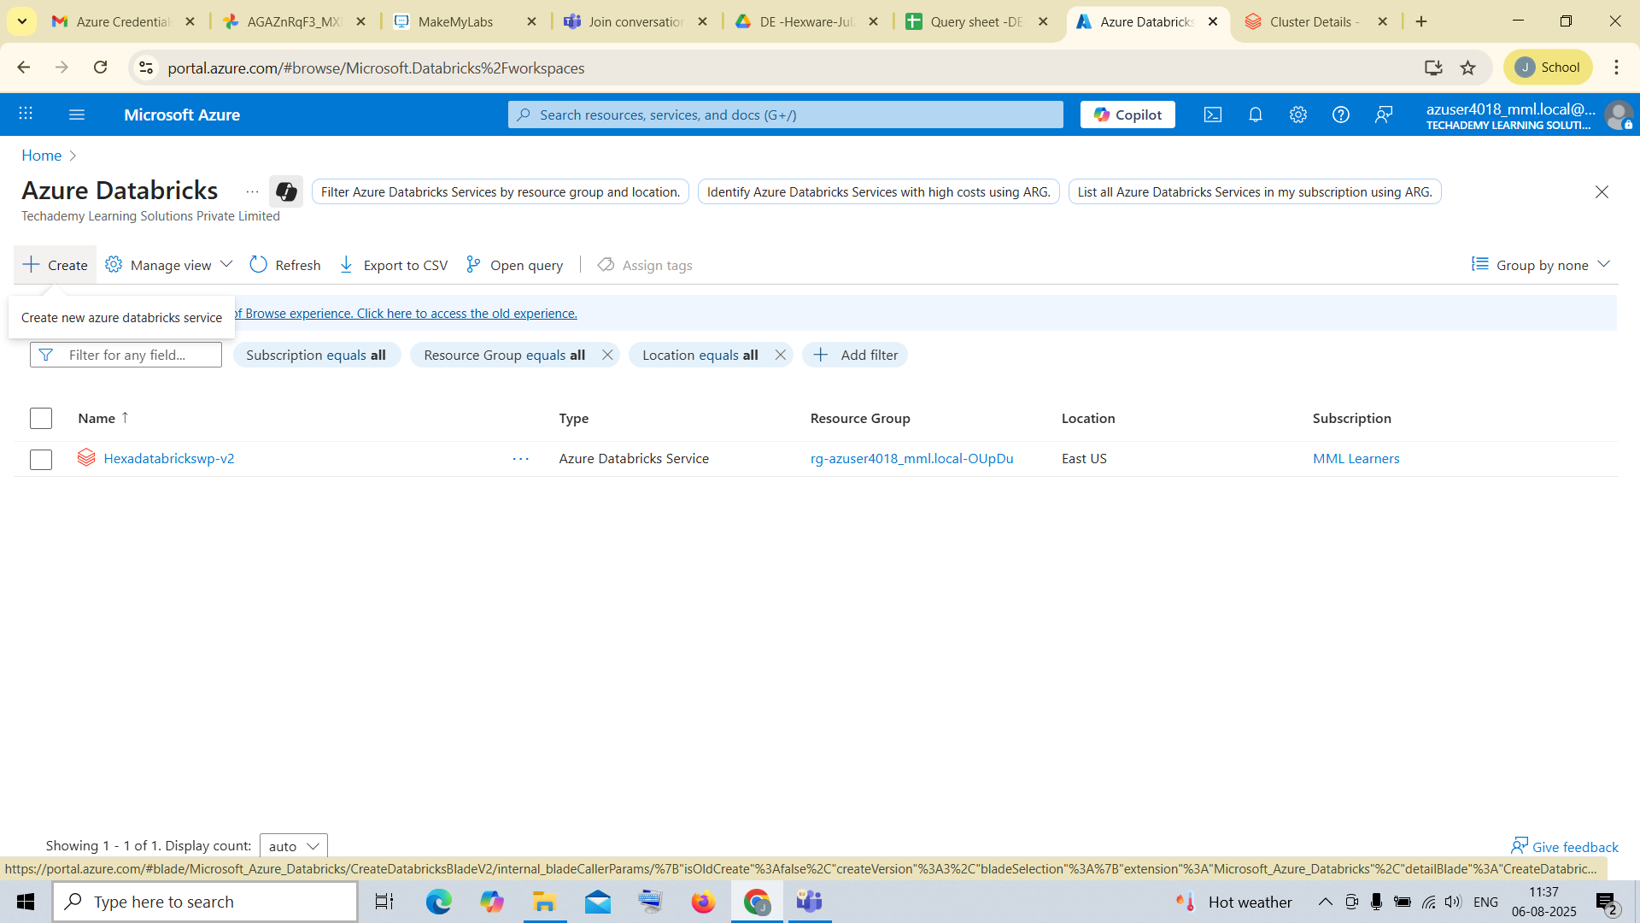

1. Enter the basics details (workspace name, region, managed resource name etc…..)

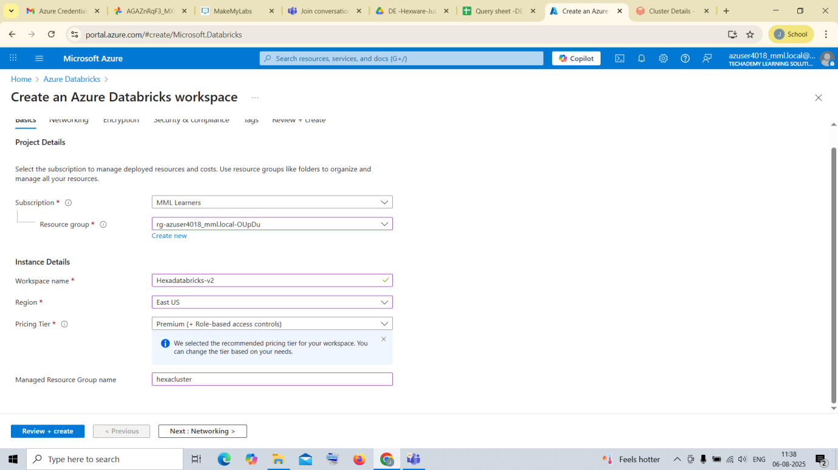

1. Enter the tag name and value for the service

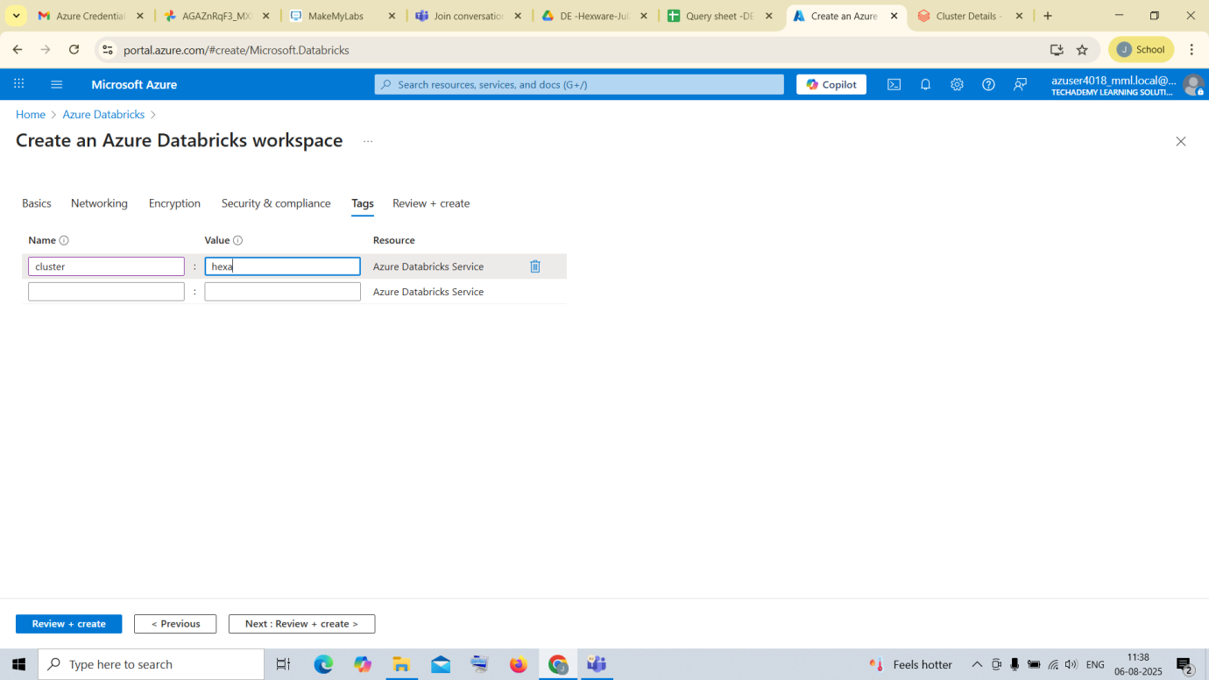

1. After that click on review and create

You can see the validation is successful

And then click on create to create your databricks workspace

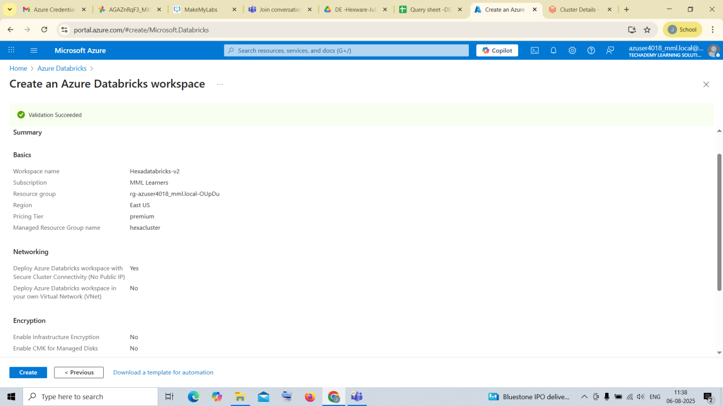

1. After creating the workspace ,enter into it and launch the databricks workspace

Click on launch workspace

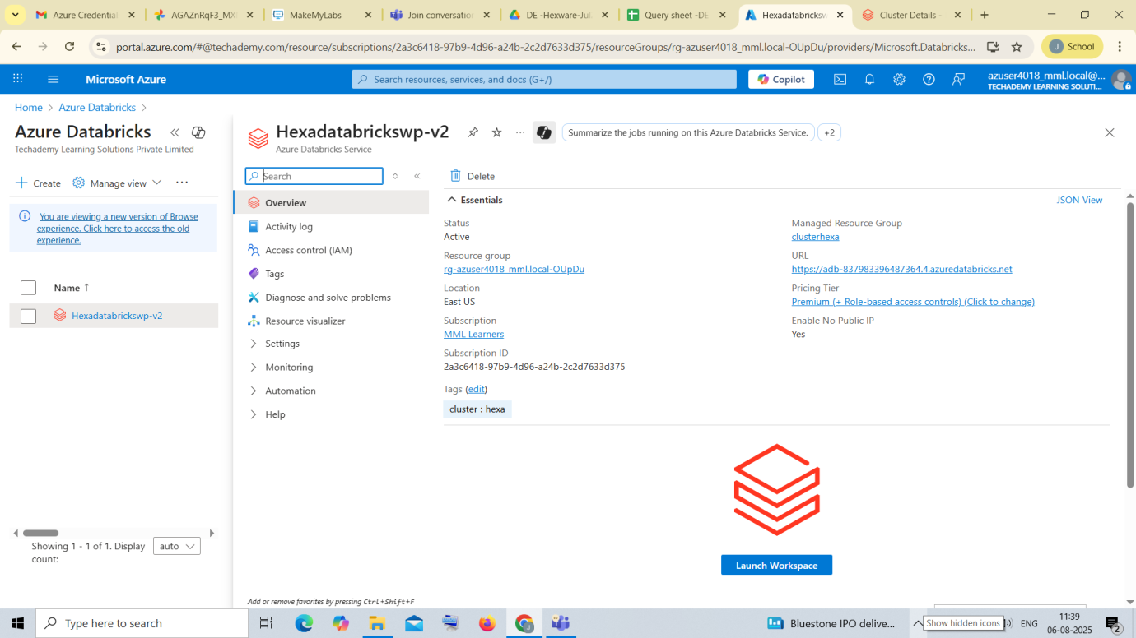

1. After entering into Microsoft Azure Databricks

Create a compute

For creating it go to compute on the left bar and click on create compute

Give the details according to your needs

Example is given below:

